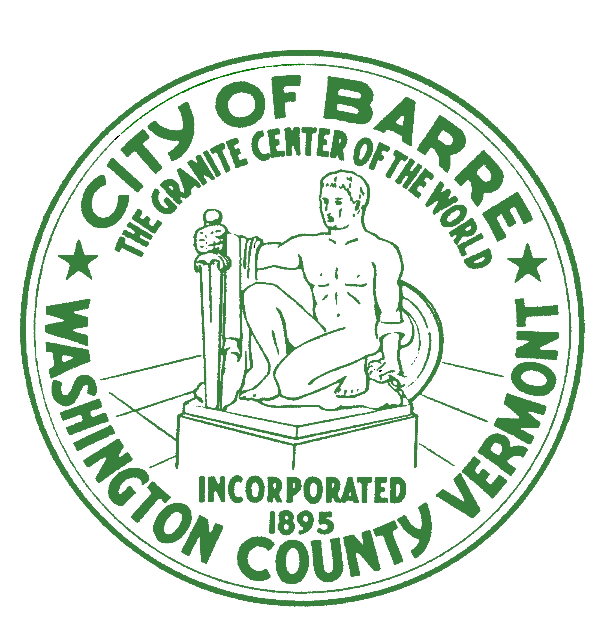
CITY OF BARRE

NOTICE
of
SUMMER STREET
TRAFFIC PATTERN CHANGE

On Tuesday, April 23rd, the Barre City Department of Public Works
will be repairing the Summer Street retaining wall in preparation for installation of the Rotary Mural. A two-way lane shift will be implemented to allow for this work. This lane shift will be located between Pearl Street (Summer Street Auto) and Buzzell Place (O’Reilly Auto Parts). The duration of this change is anticipated to be approximately 4 weeks to allow for the wall repair and installation of the mural panels.

