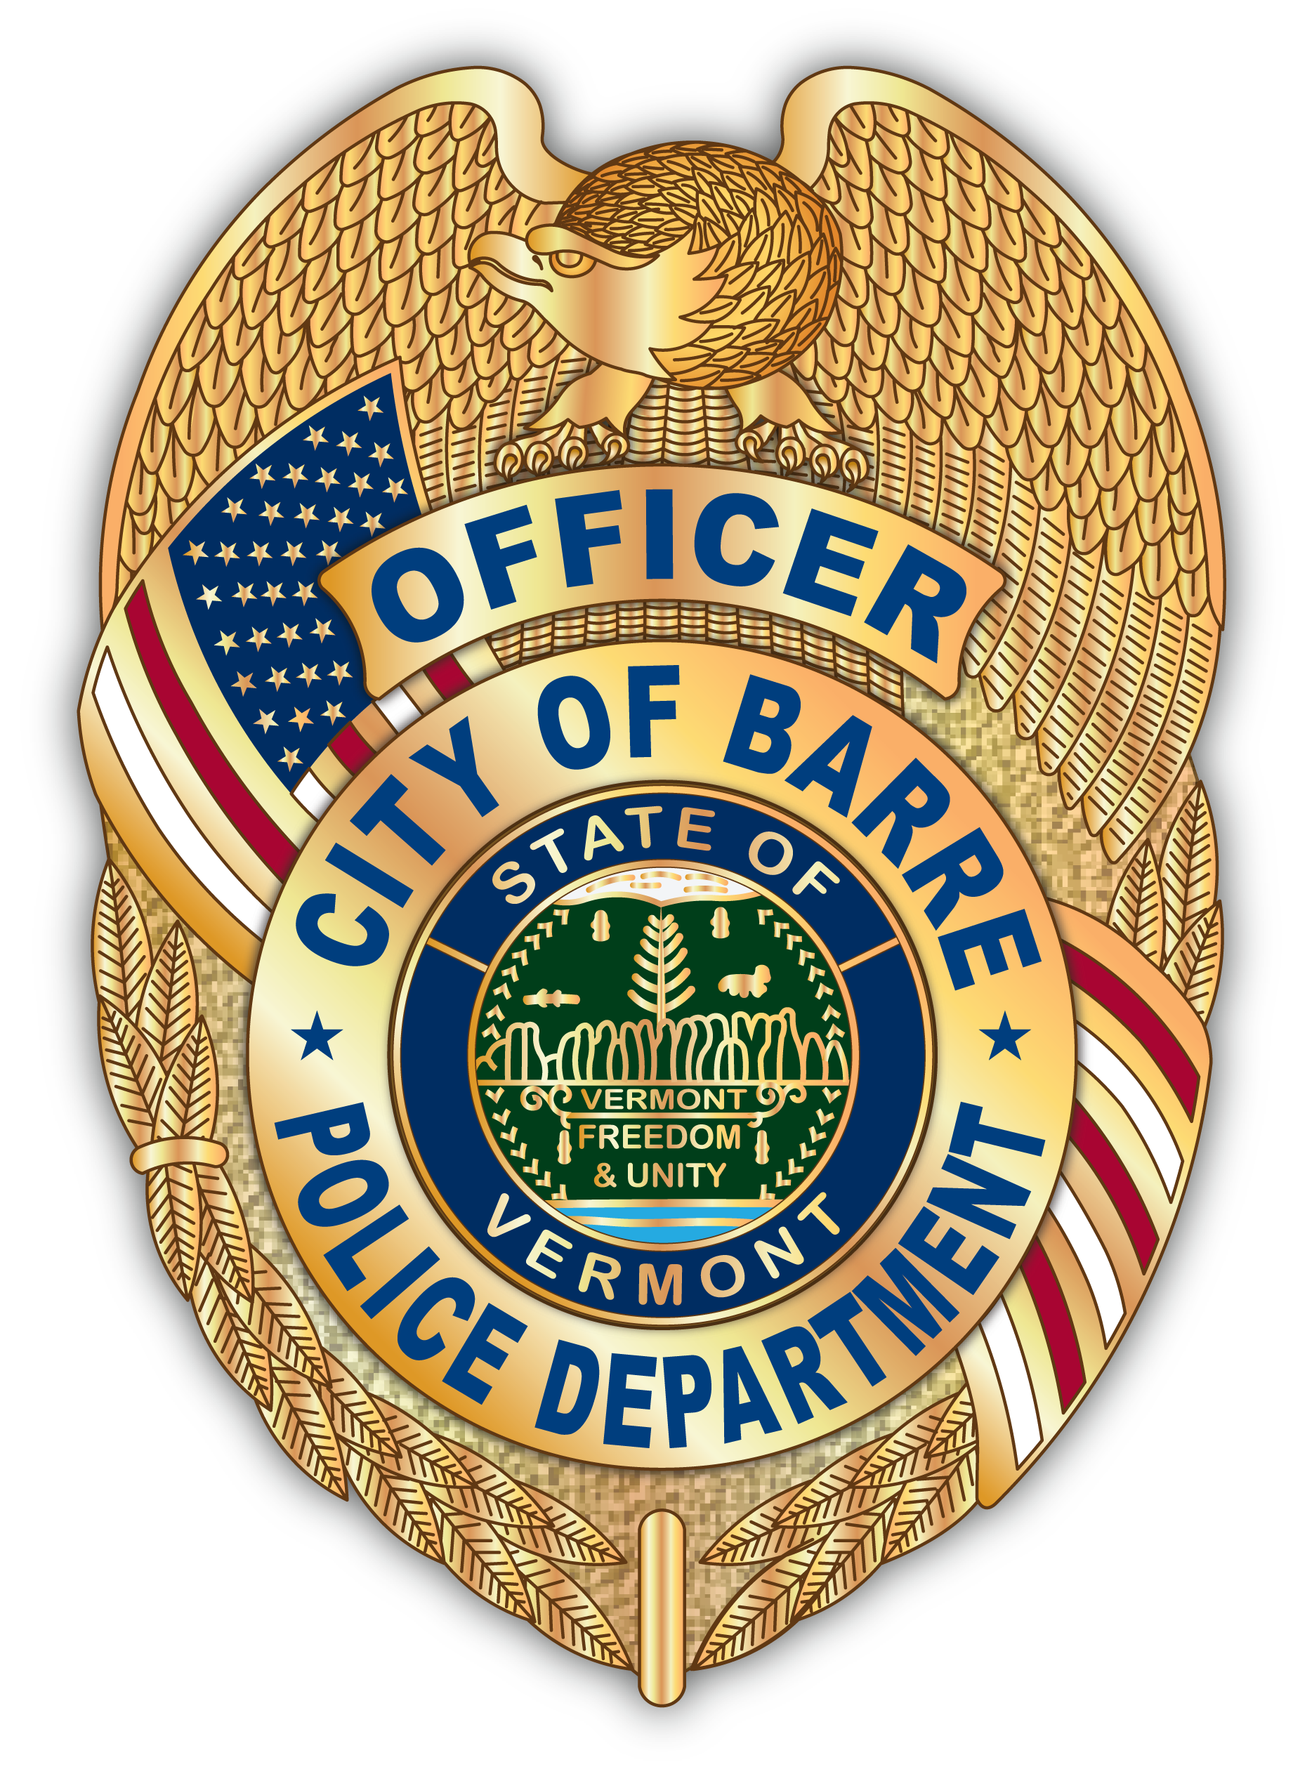
CITY OF BARRE PUBLIC SAFETY

TIMOTHY J. BOMBARDIER Director of Public Safety
15 Fourth Street
Barre, VT 05641
www.barrecity.org

Officer Fleury Lucas Herring
Neighborhood Watch Mayor
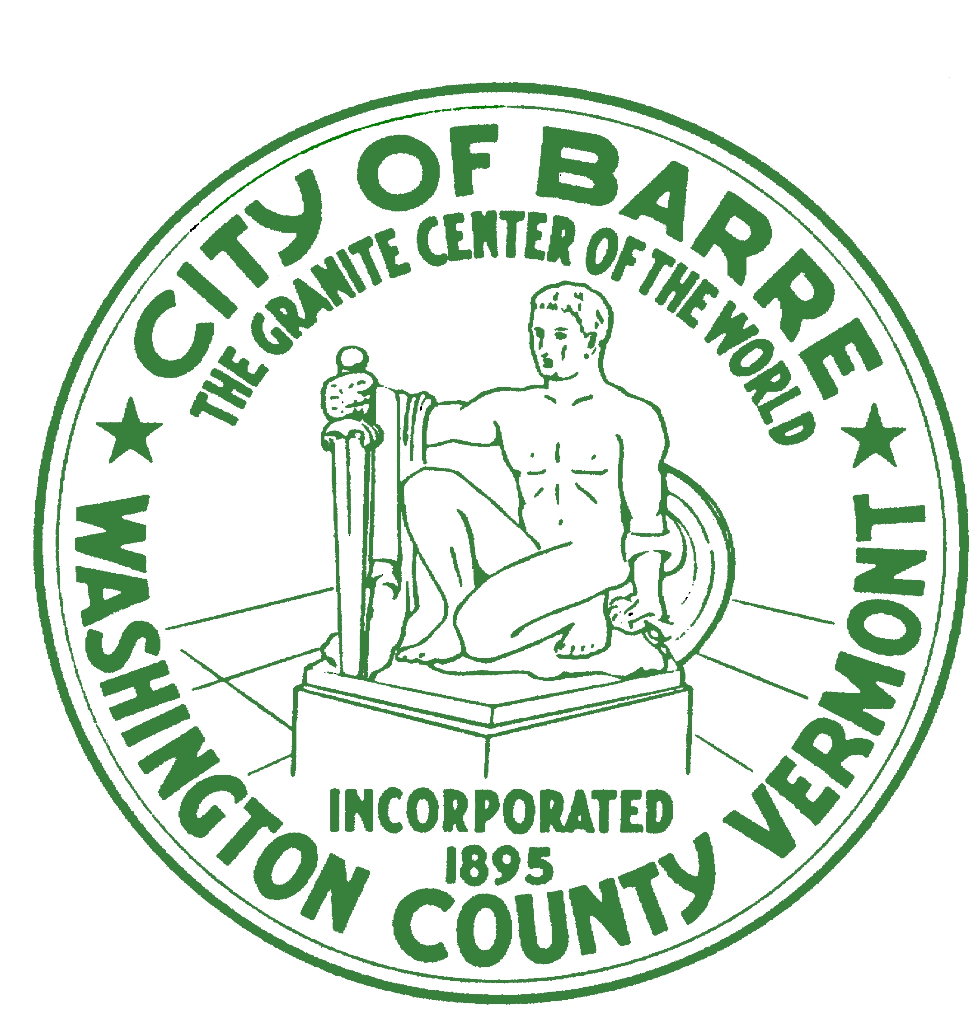

BARRE CITY NEIGHBORHOOD WATCH PROGRAM

What: Organizational Meeting – Tilden House

When: January 10th, 2019 @ 6:00 PM

Where: Community Room

Come and join us and be part of a group of neighbors and friends dedicated to making Barre City a safer place:

- Discuss current issues in your location
- Gather contact information

Contact people should you have any questions are:

Chief Timothy Bombardier 476-6613 Tim.Bombardier@vermont.gov
Officer Jason Fleury 476-6613 Jason.Fleury@vermont.gov

