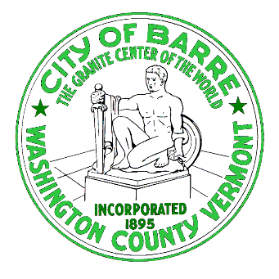

**Department of Public Works**

**6 North Main St Suite 1**

**Barre, VT 05641 (802)476-0250**

Wastewater Rate Increase Overview

Recently, in response to a continuing annual deficit in the Wastewater Enterprise fund the wastewater treatment rates were revised. The rate has two components – a base rate which covers some administrative and fixed costs and a usage rate that is intended to reflect the influence of variable operating costs. These two parts provide a composite rate that is responsive to the amount of sewage generated, while providing base income to address principal administrative costs. In the review of the rates, the City administration was directed to examine alternative rate structures to fairly allocate costs in a manner that does not burden single family homes in response to testimony provided by citizens.

The sewer rate increases – were **4% on the** **base charge** of $44.28 which goes up by **$1.77 quarterly** to for residential users. The usage charge increase based on the 20% rate increase varies greatly based on your usage.

For typical low usage residences e.g., 1 plus person households (no outside watering) is expected to go up by **$2.70 quarterly for usage** from $13.50 to $16.20. Our projection for previous billing in this example was 44.28 plus 13.50 equals $57.28 in this example. Low water users (15th percentile) see a composite rate increase of 7.8% and an **increased amount of $4.46** to $62.26 total.

For an average water user e.g., the costs increase is **$6.48 quarterly for usage** from 32.40 to 38.88. Our projection for previous billing in this example was 44.28 plus 32.40 equals 74.68. Average water users (50th percentile) see a composite rate increase of 11.1% and an **increased amount of $8.24** to $82.92 total.

For high usage residential, the cost is expected to go up by **$14.04 quarterly for usage** from $70.20 to $84.24. Our projection for previous billing in this example was 44.28 plus 70.20 equals $114.48. High residential water users (85th percentile) see a composite rate increase of 14% and an **increased amount of $15.80** to $130.28 total.

There is a chart that describes a comparison of Barre’s water and sewer rates with other communities provided to help with context of our system costs

What are you being asked to pay for with this increase?

The city has held rates so low that we aren’t taking in the costs of operations. Several keys areas are seeing critical increases in costs. They are 1) sewer response and repairs which are increasing in frequency and costs as our system ages 2) energy costs for fuel and electricity have increased as well as increases in consumption in several areas 3) wastewater solids handling costs and especially 4) wastewater treatment plant repair costs.

In the past 24 months, we have had to rebuild major pieces of equipment for settling processes, digestion processes (3x) with significant repairs to boilers, heat exchangers and pumps to move wastewater solids around the plant for processing. Changes in safety standards have mandated improved motor/power covers, better employee protection or isolation and improved training. These are important and necessary items. The plant is now 25 years old, and many components are simply worn out, and repairs cannot be postponed or the plant will fail. All failures are costly – both in environmental terms and financial terms.

Those are the items that have caused the City to expend more than annual revenues. There is no reduction in expense that can be reasonable projected. Grant receipts and major equipment purchases buoyed revenues with the purchase of the new sewer vacuum truck ($368,000) for one fiscal year. But there aren’t additional opportunities on the horizon.

The City is looking at a thorough review of the plant, to determine how to limit both uncertainty in expenses and in reliability. We hope to improve our capital position and decrease or at least stabilize operating expenses with that effort.