**CITY OF BARRE**

**PUBLIC BODY DRAFT MEETING MINUTES**

**Committee/board:** Diversity and Equity Committee

**Date of meeting:** Monday, November 2, 2020, 6:15PM

**Location of meeting:** Zoom Videoconference with Call-in Option

**Board/committee members in attendance:**

* Ellen Kaye
* Danielle Owczarski
* William Toborg
* Joelen Mulvaney
* Marichel Vaught
* Christopher Roberts

**Board/committee members absent:**

* None

**Others in attendance:**

* Steve Mackenzie (City Manager)

**Topic(s) Discussed**

1. Call to order at 6:17PM.
2. Adjustments to the Agenda.
   1. No adjustments. Danielle is leaving early and Marichel will take meeting minutes after 7PM.
3. Approval of Minutes from Previous Meeting
   1. Meeting minutes approved.
4. Old Business:
   1. Sub-committee reports (if any)
      1. no report
   2. Definitions - Ellen
      1. Ellen shared definitions prior to meeting - she defined inclusion, barriers, culture, and equity
      2. Tailored it to a municipality and created each definition based on feedback from the group
      3. The group worked on the definitions document together
         1. Equity
            1. Danielle - thought definitions were clear and concise, Joelen - action oriented, Marichel - clearly defined
         2. Systemic/structural barriers
            1. Group is okay with definition
         3. Inclusion
            1. William - suggested adding “seemingly” before unaffected, the committee decided the prior text “may remain hidden” covers that concern. William was okay to not include it.
            2. Chris suggestion to add individuals before regardless to include all people more clearly
            3. Remove “and other characteristics” and instead add “including but not limited to race…”
         4. Culture
            1. William suggested to add religion to the culture definition, the group agreed.
            2. Joelen suggested to add heritage to the culture definition, the group agreed..
            3. Question from the group about the last sentence of the culture definition.
      4. Joelen suggested the group add definitions to this list that are in the Flag Policy to better define the flag policy in the future.
      5. **Ellen** will update the definitions document based on meeting feedback and share with the group to discuss at the next meeting.
   3. Flag Policy - Marichel/Chris
      1. Committee reviewed the flag policy from the last meeting that Chris and Marichel worked on.
      2. Committed added non-substantive changes.
      3. William questioned about having to wait 5 days before flying flag at half-mast - could this be done sooner - a question mark can be added to this section for the Council’s review.
      4. **Joelen** will call town manager to see if we can get on the agenda for council early as possible.
      5. Changed language in 6.f.i to partisan political from political
      6. Flag the special mayor privilege for flag flying - William suggested to add the language in the mayor provision “in accordance with the above” in number 6. The group agreed and will flag it for council.
      7. Marichel began recording minutes at 7 pm
      8. Chris said he is unable to access the D&E Committee drive in Gmail. Marichel said she’d pass the message on to Danielle.
      9. Marichel said she will place a clean copy of the flag policy draft in the drive. Once everyone has taken a look at it and given additional comments, it will be forwarded to Steve McKenzie, City Manager.
5. New Business:
   1. Black Lives Matter (BLM) special flag request – Joelen
   2. Joelen’s letter specifically speaks to including the BLM flag request in reference to Barre City’s resolution. Flying the flag is symbolic of the dedication the city has to move in the direction addressing racism in the community.
   3. At the next City Council meeting, Nov. 10, when the D&E Committee proposes the flag policy, we will also request the city to fly the BLM flag.
   4. Joelen asked the group when should the flag fly (Juneteenth, MLK Day, Black History Month?) Ellen and Marichel said it should be as soon as possible.
   5. William does not support flying a BLM flag. He would support flying a flag stating “All Black Lives Matter” because then people wouldn’t see it as support for the “organization” Black Lives Matter. There is an association with BLM and rioting.
   6. As a side, Chris will forward the committee members an essay he wrote.
   7. Ellen disagreed with William. She supports BLM and explained it is a statement, without any association with the organization. She rejects that white people would rewrite the statement. She doesn’t want to retract the statement Black Lives Matter.
   8. Joelen said we should resist the propaganda that has come up with the statement. Joelen spoke about the history of BLM.
   9. Ellen said she’d like to see City Council back an art project promoting racial justice.
   10. Ellen suggested that William provide education to people who don’t back BLM and believe it is a divisive organization.
   11. Marichel moved to recommend City Council to fly the BLM flag as soon as possible in conjunction with presenting the flag policy proposal.
6. Set next meeting Date: Monday, November 16, 2020, 6:15PM
7. Round Table
   1. Ellen read a letter by Danielle about seeing the confederate flag flown with the American flag and political flag in downtown Barre. The letter was read as follows:
      1. “On my way to the local Hardware Store tonight on Main Street, I witnessed a sight that left me beyond upset and discouraged. As my eyes set on the scene at the center of the intersection in Barre City amidst the horn honking and engine revving, my heart began beating hard in my chest and my throat tightened up. I was experiencing a fight or flight response, a fear response.

At that moment I was reminded of words spoken by one of our committee members at a previous meeting. After hearing the testimonies of people of color who experienced racism in the Barre community and greater Vermont, a committee member remarked that they did not see any confederate flags in Barre and that racism was not a political issue in the way the victims described it. Later in the night the committee member suggested there be open communication between BIPOC people and the political supporters they identified. I was at a loss for words at that point and had to leave the meeting early for a previously scheduled engagement, much like tonight.

What I saw when I made my way to the downtown was a large confederate flag waving in the forefront along with the American flag and other political flags. The person holding this flag did not appear to be receiving disagreement from the other people in the group. They were bold and proud of their statement. They were not feeling fear. They felt safe to express their racist sentiment in our city.

My heart breaks for the BIPOC members of our community that have to witness this hate in their community. I DO NOT in any way believe they misinterpret their experience. We cannot blame the victims of racism. Our duty as the Diversity and Equity Committee is to stand in solidarity with our BIPOC community and do the hard work so they can rest and repair the damage done by their own neighbors, our neighbors.”

* 1. Chris was horrified that Danielle had to witness that.
  2. William said that he will approach scenes such as that, displaying confederate flags, to express how inappropriate it is and called for committee members to do so as well.
  3. Joelen expressed gratefulness to the committee for their work and to the city for creating the committee.
  4. Marichel said that she has tried to recruit people of color to join the committee but the sentiment is that their presence wouldn’t make a difference. As a community that is mostly white, Marichel felt that strong white voices as allies should be recruited to convince other white people who don’t back BLM that racism and systemic oppression do exist.
  5. Ellen moved to adjourn the meeting, seconded by William.

1. Adjourned at 7:43 PM.

**Action items**

1. **Ellen** will update the definitions document based on meeting feedback and share with the group to discuss at the next meeting.
2. **Joelen** will call town manager to see if we can get on the agenda for council early as possible.
3. Chris said he is unable to access the D&E Committee drive in Gmail. **Marichel** said she’d pass the message on to Danielle.
4. **Marichel** said she will place a clean copy of the flag policy draft in the drive. Once everyone has taken a look at it and given additional comments, it will be forwarded to Steve McKenzie, City Manager.

**1) Motion:** Move to adopt minutes as they are.

**Mover/Seconder:** William/Joelen

**Result of vote:** 5 in favor

**2) Motion:** Move to recommend City Council to fly the BLM flag as soon as possible in conjunction with presenting the flag policy proposal.

**Mover/Seconder:** Marichel/?

**Result of vote:** 4 in favor - Joelen, Ellen, Chris, Marichel / 1 not in favor - William

**Meeting adjourned:**

**Mover/Seconder:** Ellen/William

**Time:** 7:43 PM

**Next meeting date/time/location:** Monday, November 16, 2020, 6:15PM via Zoom

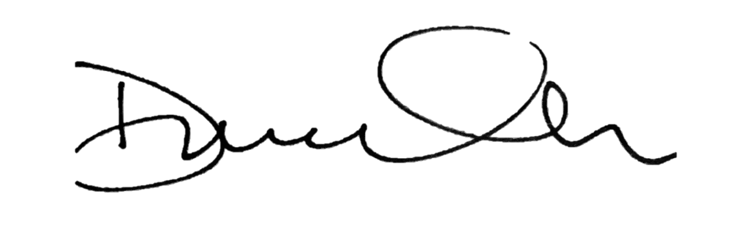

Danielle Owczarski