***City of Barre, Vermont***

***“Granite Center of the World”***

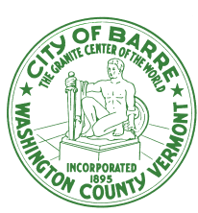

**Jeff Bergeron**

**Director of Buildings and Community Services 20 Auditorium Hill**

**Barre, Vt. 05641**

**Office: 802-476-0256**

**Fax: 802-476-0264**

**Cell: 802-498-3495**

**Email jbergeron@barrecity.org**

November 25, 2020

As per the Governor’s announcement on Tuesday, November 24, “pausing” youth recreational activities and high school sports, the B.O.R. ice arena will remain closed until further notice. Questions may be directed to the Barre City Recreation Department at 802-476-0257 or the Facilities Department at 802-476-0256.