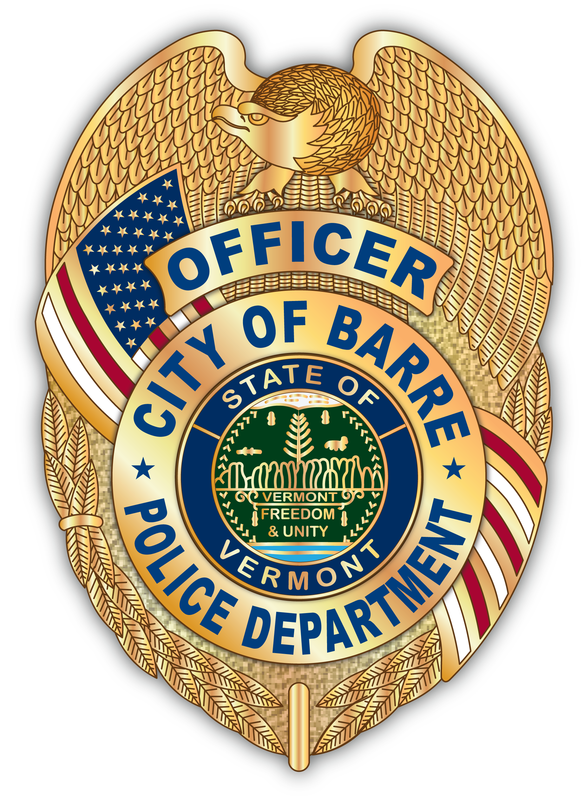
CITY OF BARRE PUBLIC SAFETY

TIMOTHY J. BOMBARDIER
Barre City Police Chief
15 Fourth Street
Barre, VT 05641
www.barrecity.org

Officer Fleury Lucas Herring
Neighborhood Watch Mayor
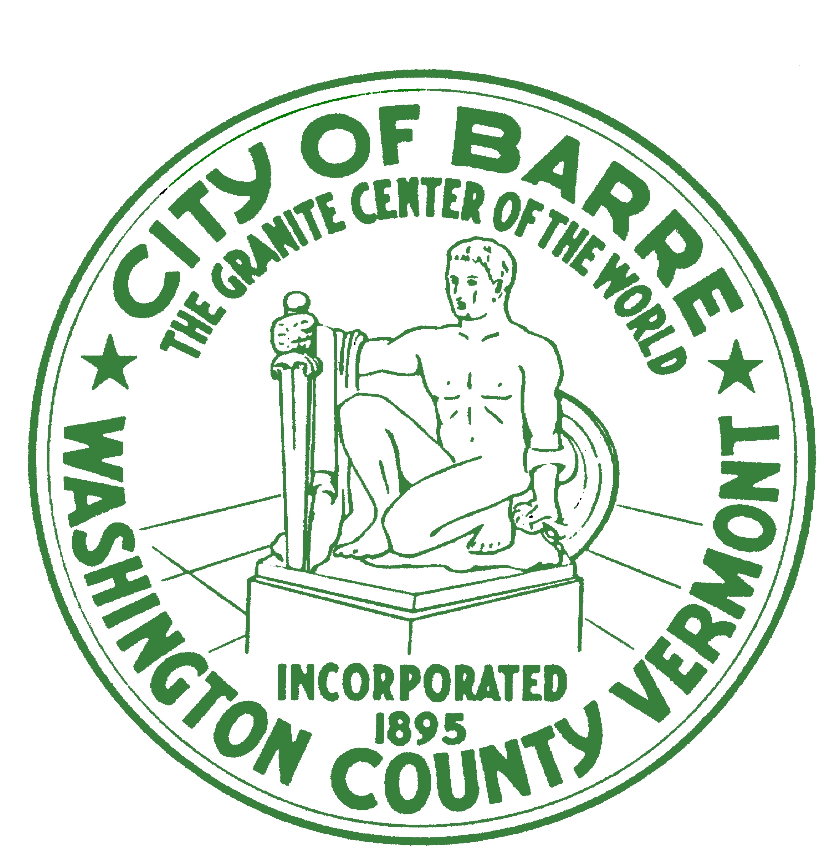

BARRE CITY NEIGHBORHOOD WATCH PROGRAM

What: Neighborhood Watch Organizational Meeting – Highgate Apartments

When: May 22nd, 2019 @ 6:00 PM

Where: Highgate Community Room

Come and join us and be part of a group of neighbors and friends dedicated to making our neighborhood a safer place:
- Find out what a Neighborhood Watch does
- Discuss current issues in your neighborhood
- New Recruitment
- Gather contact information

Contact people should you have any questions are:

Chief Timothy Bombardier 476-6613 Tim.Bombardier@vermont.gov
Officer Jason Fleury 476-6613 Jason.Fleury@vermont.gov
Det. James Pontbriand 476-6613 James.Pontbriand@vermont.gov

